Created two EC2 instances. One Jenkins master with Java 17, maven, tomcat, git and Jenkins installed and 2nd otherEc2 with java 17 and tomcat installed.
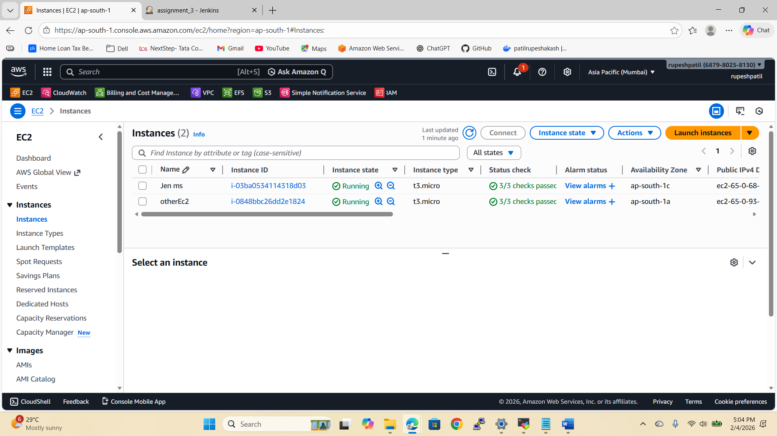

Created the JOB and created the minimalistic CICD pipeline which will create the war file in target folder
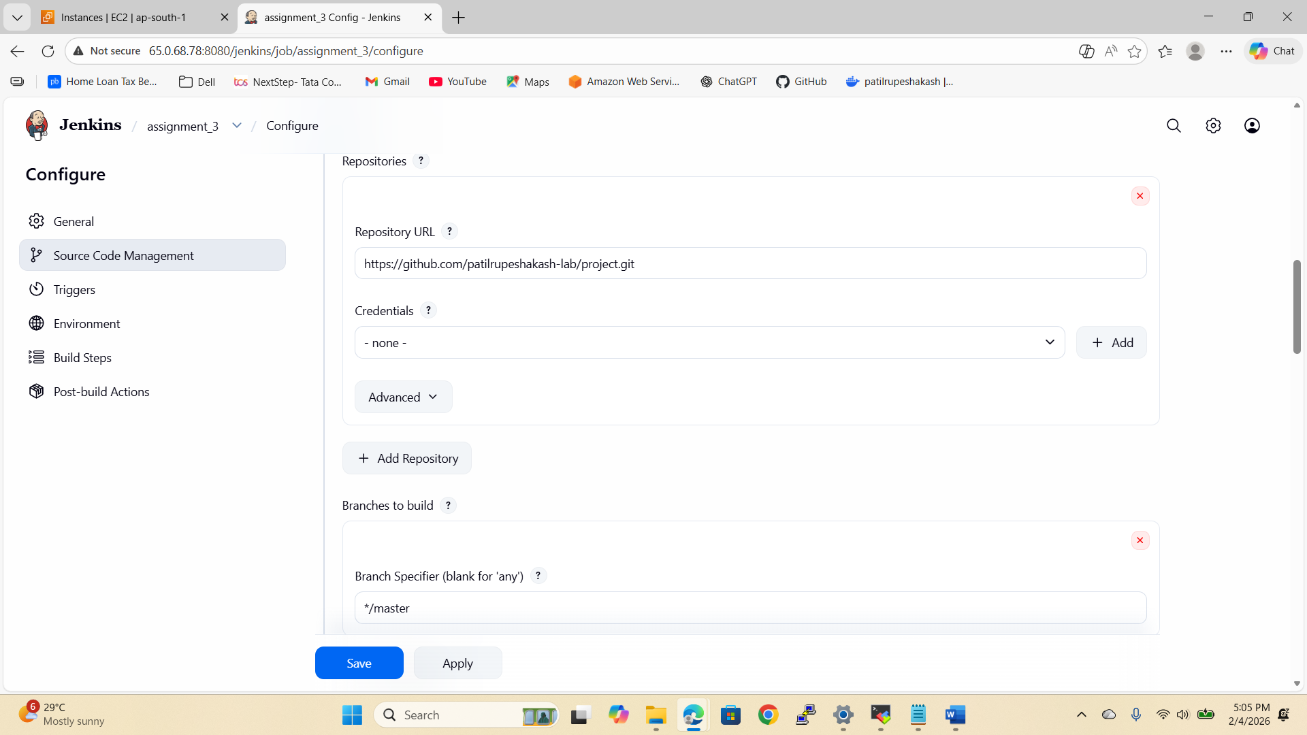
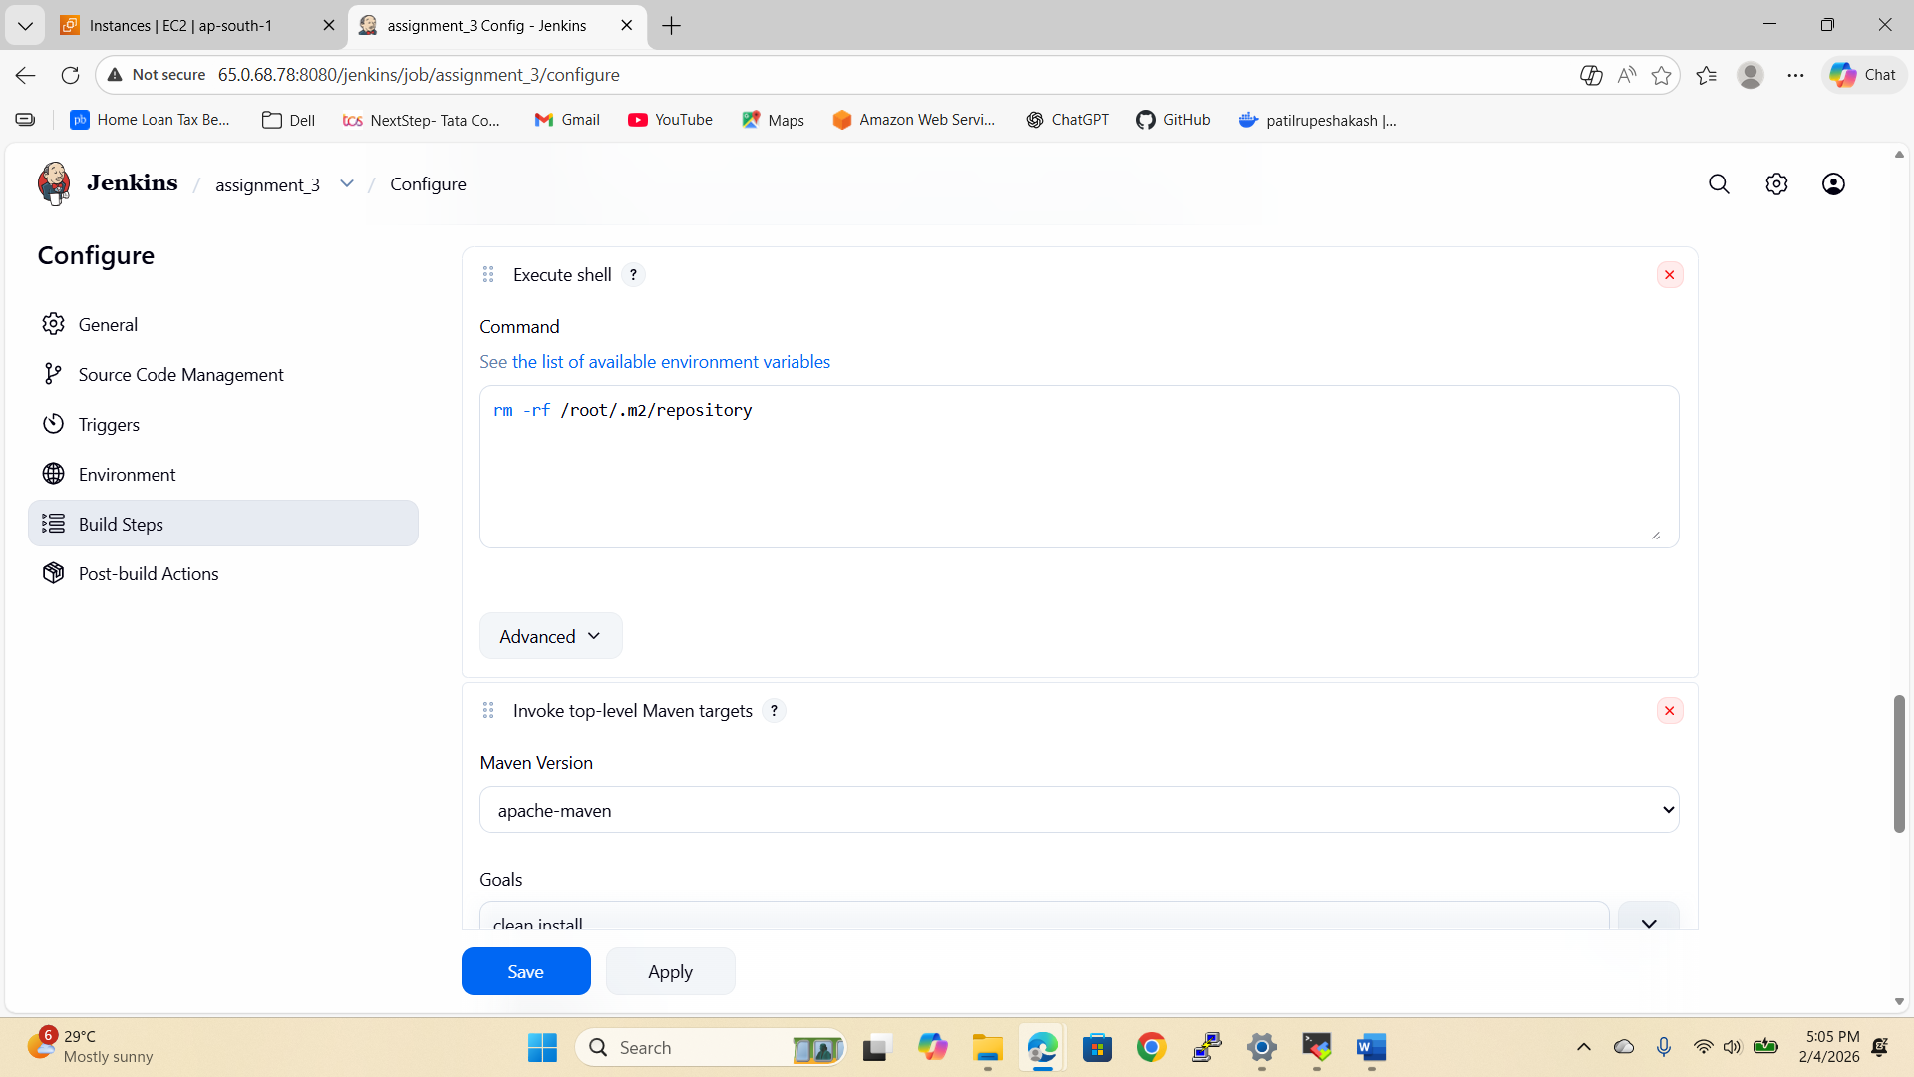

Created key.pem file in Jenkins master and with the help of scp (secure copy) command copied the war file from Jenkins master to the otherEc2 instance which is not slave
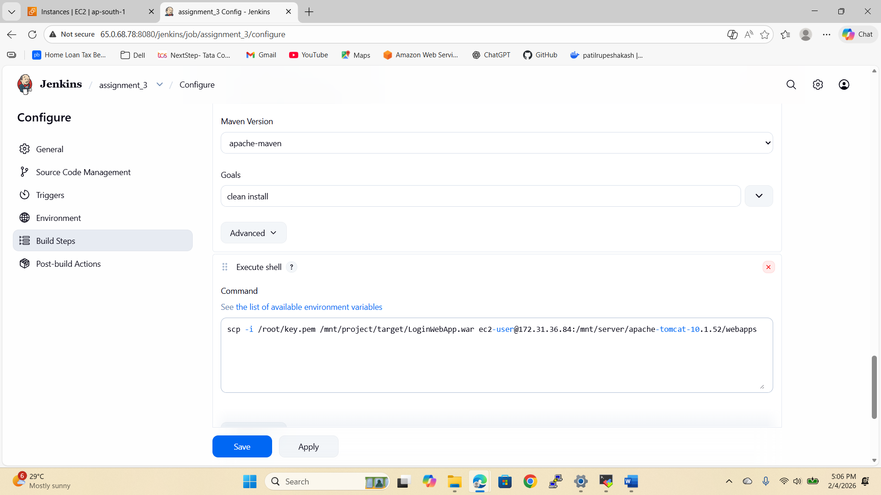

Run the build
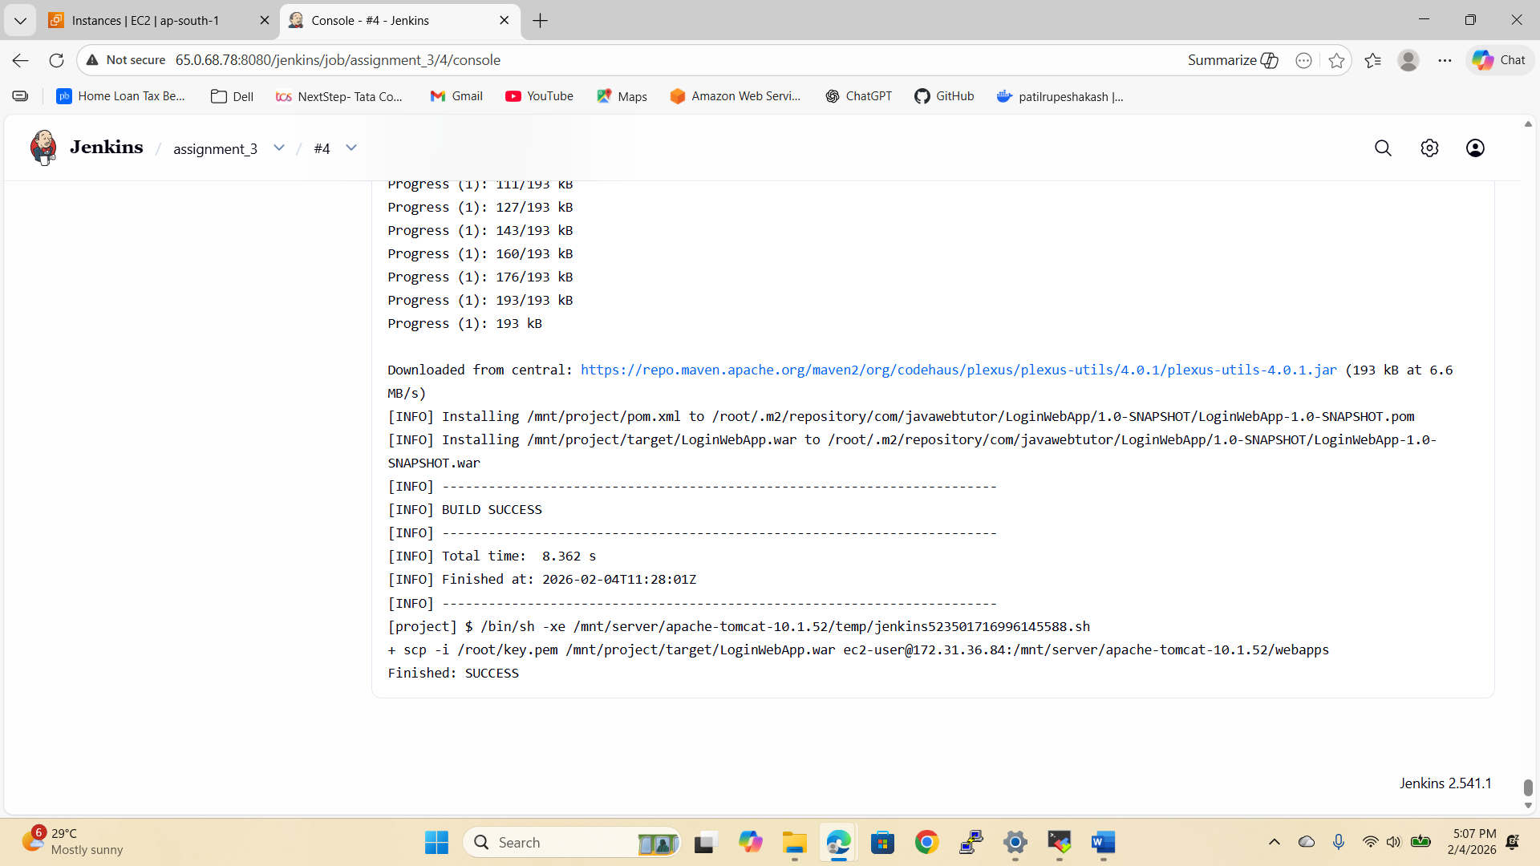

Copied the public ip of OtherEc2

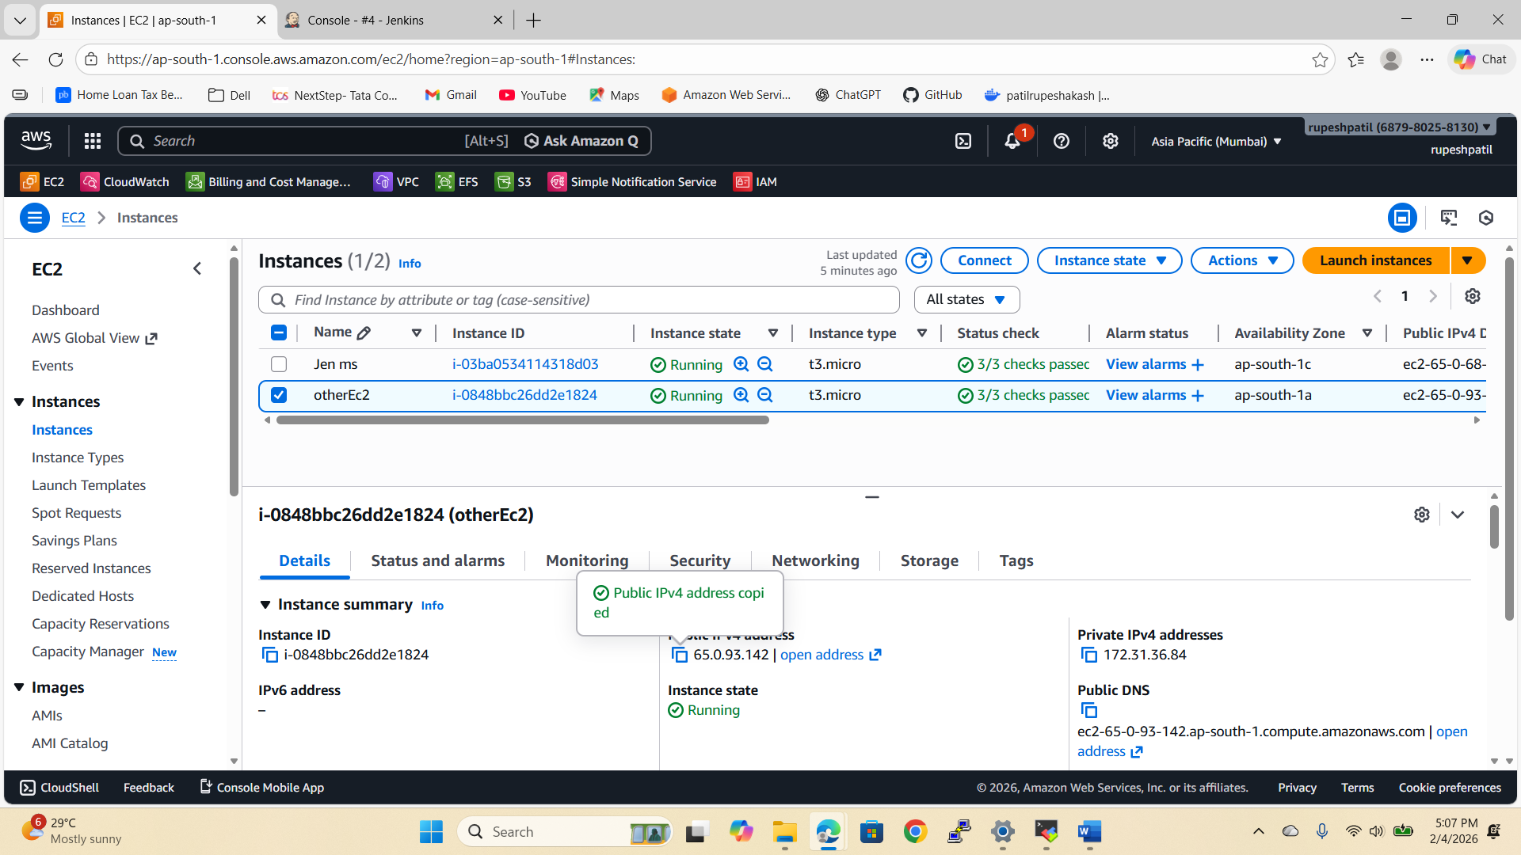
Hosted the website
